<http://tashian.com/htmlguide/password.html>

fdf6e1 background pink

Sending out Save the Dates early mid September

Date: 6/25/11

Venue: Sonoma, CA

Play with the theme of Napa, and wine country

lechang.com

Welcome – day countdown

About Us – About us, How we met, How he proposed

Wedding Schedule – Date, Venue, Directions, Parking (hours) Maps

Reception

Rehearsal dinner

Travel and Lodging– airline websites, rental car sites, hotel

Date: 6/25/2011

VenuE: Atwood ranch, Sonoma, Glen Ellen, CA

Take a shuttle into this venue. Maps and directions from SFO & Oakland airport to Sonoma. Shuttle makes stops at most of the hotels. Shuttle service will become more clear. Shuttle service to be provided from hotel to venu and back to hotel. No parking at the venue.

Lena will scan the maps and directions in.

Wine tastings, hiking, biking trails, hot spring spas, olive oil and lavendar estates. Historic state parks, Napa

**Wedding timeline:**

Date: 6/25/2011

VenuE: Atwood ranch, Sonoma, Glen Ellen, CA

3:30pm – ceremony

guests can start arriving at 3pm

Check back for updates

**Hotels**

**MacArthur Place

<http://www.macarthurplace.com/>

– primary. This is the host hotel. The Bride and Groom and most of the bridal party will stay here.

Hotline, reference number:

**LODGING should be booked immediately because NASCAR is having a race the same weekend so lodging will go fast. Cheaper and more available. High priority to book rooms immediately.**

707-933-3179

They should call between 8 and 4pm M-F PT and refer to the Zee/Marcus Wedding.

Check in time = 4pm. Checkout 12noon

2 night minimum

guest room – 279

Suites - 379

**Sonoma Valley Inn**

http://www.sonomavalleyinn.com/

– 550 Second Street West, Sonoma, 95476 = The Best Western

Zee/Marcus Wedding

Confirmation number 81950

Guests call 707-938-9200 or toll free 1800-334-5784

Checkin time – after 4pm, checkout time 12 noon

Deposit equal to the rate of the first night will be charged to each guest at time of reservation. Reservations canceled before 72 hrs of arrival will be refunded in full

2 night minimum

Standard King – 249.99/night

Fireplace King – 279.99/night

**El Pueblo Inn**

http://www.elpuebloinn.com/

2 night minimum

Zee/Marcus wedding

1800-900-8844 707-996-3651

Adobe double – 219/night. 2 double beds

adobe king – 219/night

Sonoma king – 249/night

Sonoma queen – 289/night. 2 queen beds. fits 4

Password protected site

Rehearsal dinner: Fri 6/24, 6pm – 9pm. BBQ. Ramekins culinary school and inn 450 west spain street, sonoma, ca, 95476

Sunday Bruch: Sunday 6/26. MacArthur Place Inn & Spa. 29 East MacArthur St, Sonoma, CA 95476

Thursday night, Friday day event: Wine tour with shuttle and stuff. (Tentative thing)

Include airport shuttle info. Pick one or two that goes up there.

Save the Date:

Getting to sonoma valley info

Car rental info

Airport info

Edited list of hotels

Preferred lodging. Contact

*******************

Photo Album

//Attendants

//Gift Registries

Honeymoon

Wedding Guestbook

RSVP

Contact us

Welcome day countdown in middle

New York – About us

California

September

Playful and fun

Light Coral, gold, cream [seafoam (greenblue) ]

<http://www.nonpareilmag.com/>

<http://www.lisalefkowitz.com/>

<http://www.inspiredbride.net/links/>

<http://circle.stylemepretty.com/>

<http://www.hellolucky.com/visit-london-letterpress-save-the-date-card-chocolate-and-fuchsia.html>

<http://www.sonomacatering.com/sonoma-valley-weddings.html>

2Wire045 - 3550639868

<http://cc.wtsampledesigns-four-seasons.com/Home.aspx>

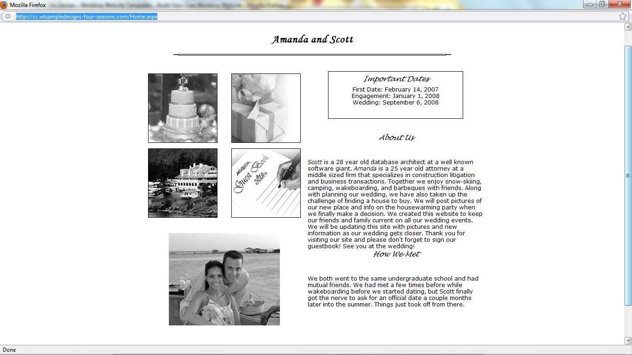

http://cb.wtsampledesigns-picture-perfect.com/

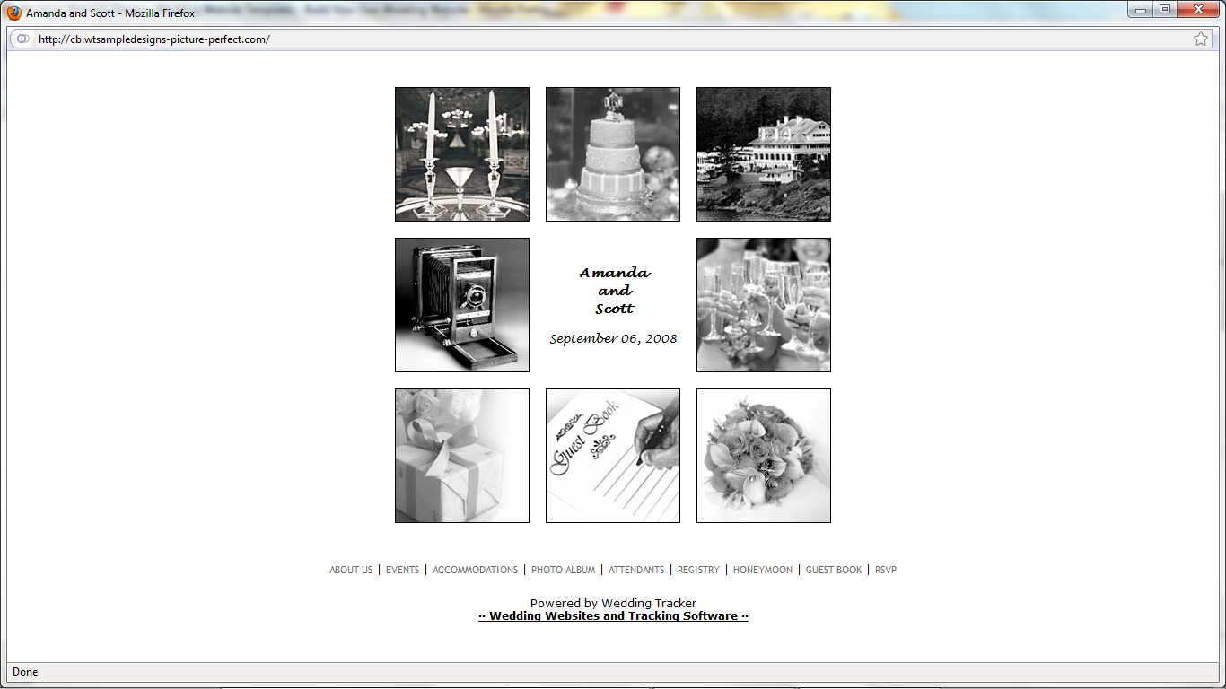

http://ea.wtsampledesigns-abstract.com/

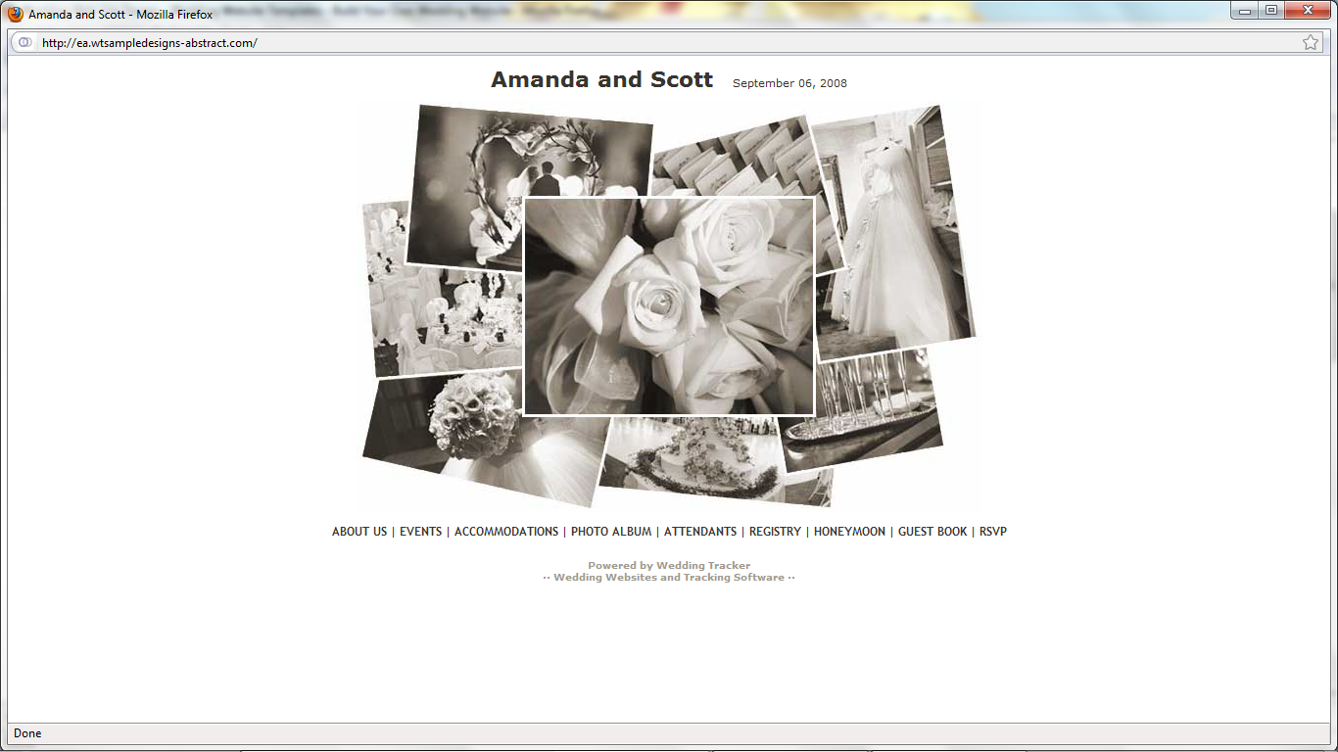

<http://stephlovesmatt.wedquarters.com/Welcome.wq>

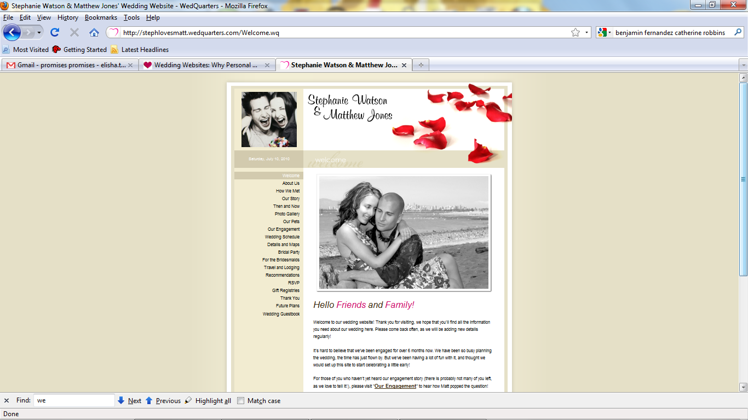

http://womenontheirway.weddingwire.com/wedding/UserViewWebsiteToolSlideshow?layoutCode=8&themeCode=81&wid=cb29d9b93e0dadd5&pid=98e6be6134f38c9c

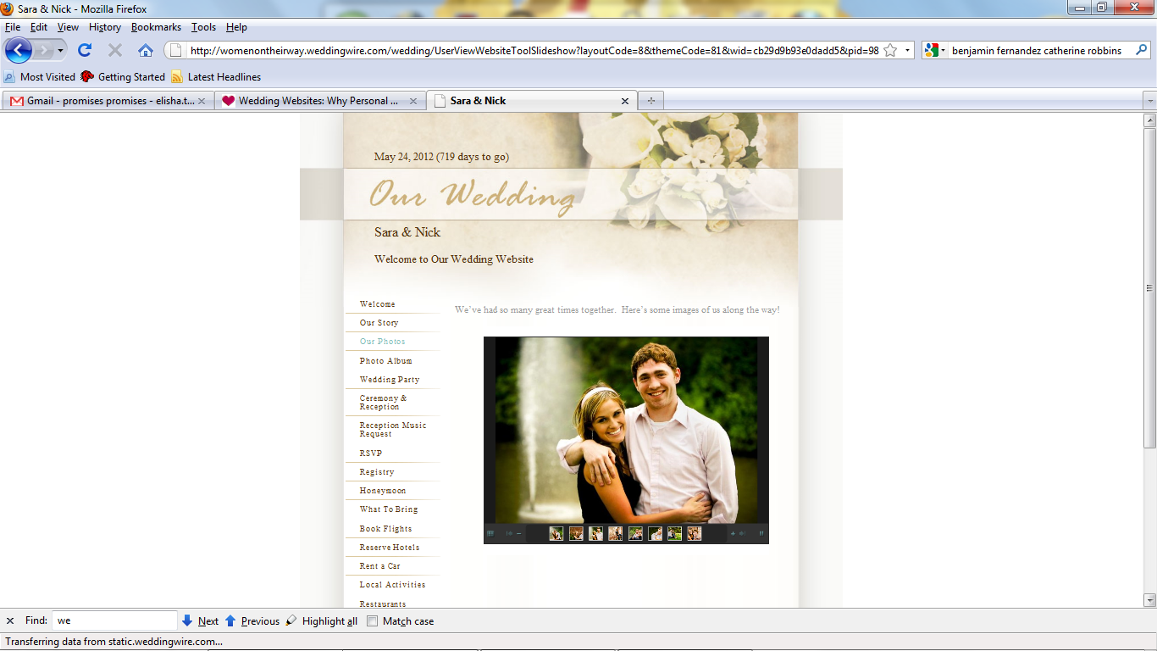

http://www.templatehelp.com/preset/pr_preview.php?i=28926&pr_code=leOM9VQSvBG6a1Nnh1le4BkXk2fJEa

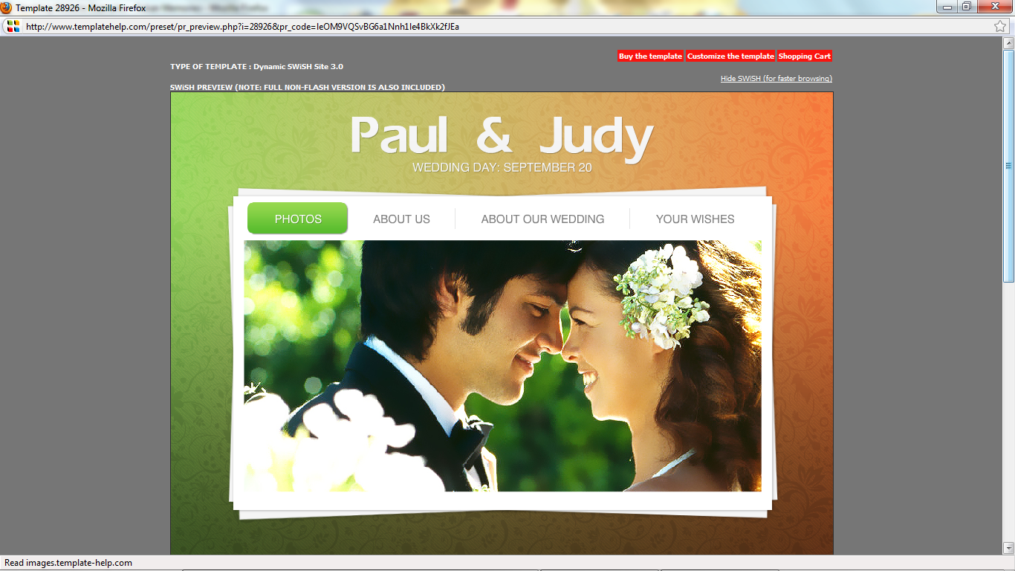

http://cms.template-help.com/magento_27243/

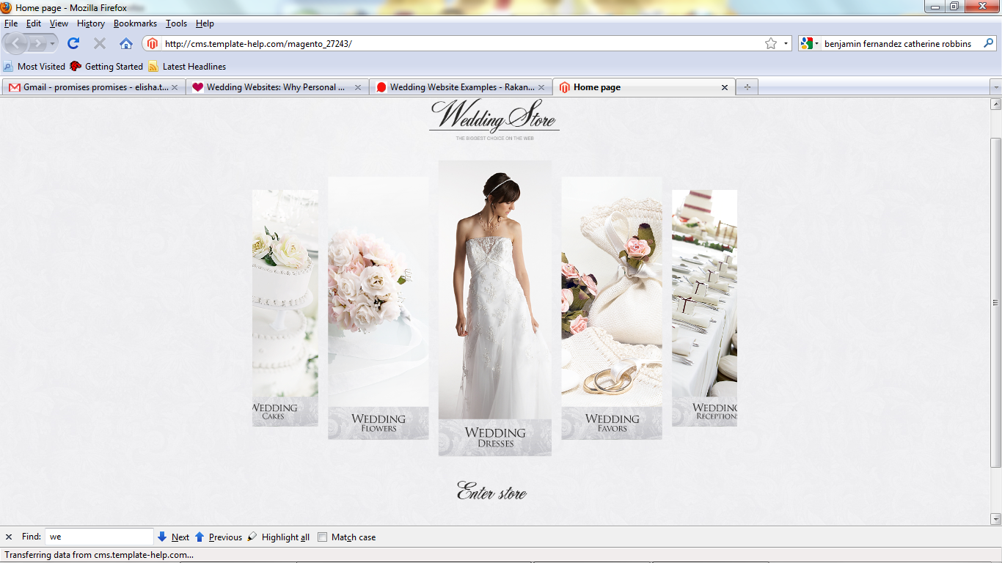

http://www.templatehelp.com/preset/pr_preview.php?i=28416&pr_code=leOM9VQSvBG6a1Nnh1le4BkXk2fJEa

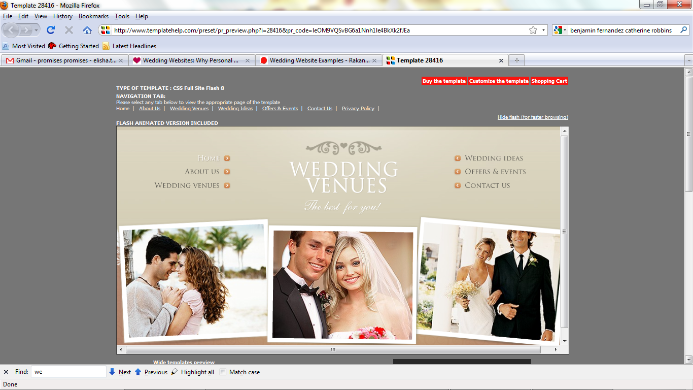

http://www.templatehelp.com/preset/pr_preview.php?i=18581&pr_code=leOM9VQSvBG6a1Nnh1le4BkXk2fJEa

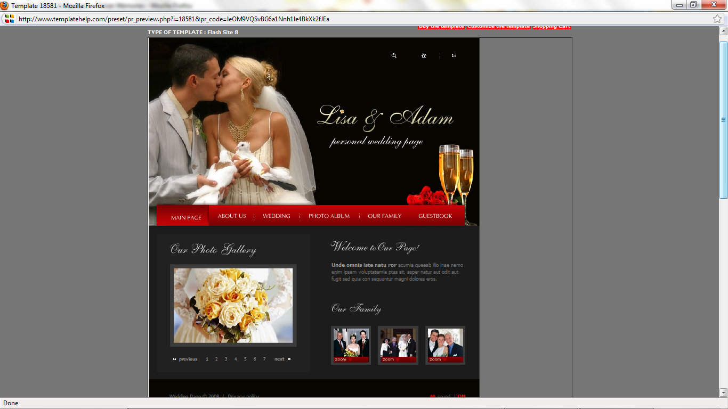

http://www.rakanmemories.com/examples/Wedding.php

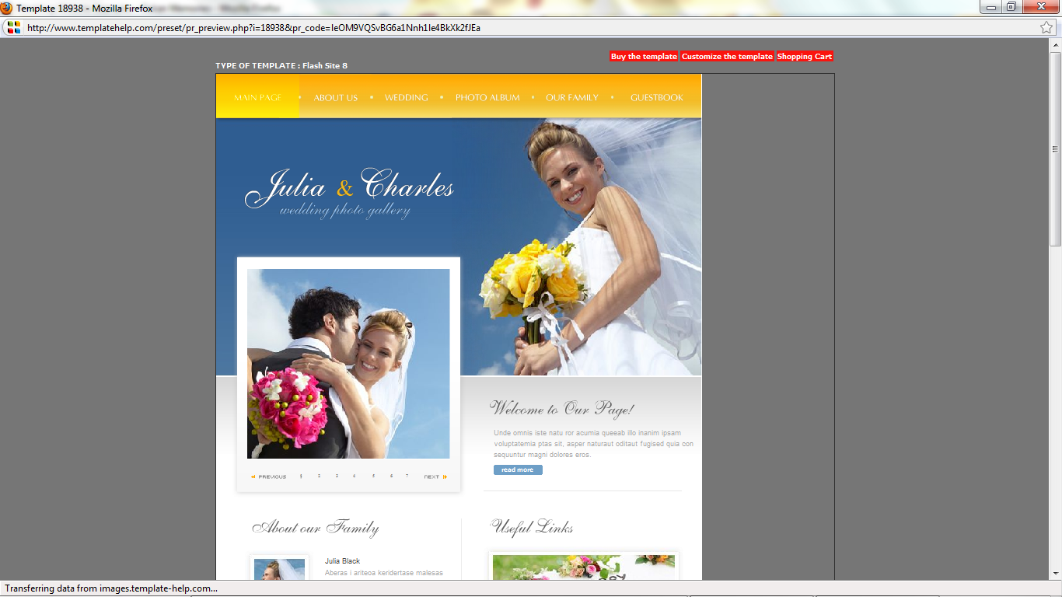

http://www.templatehelp.com/preset/pr_preview.php?i=10529&pr_code=leOM9VQSvBG6a1Nnh1le4BkXk2fJEa

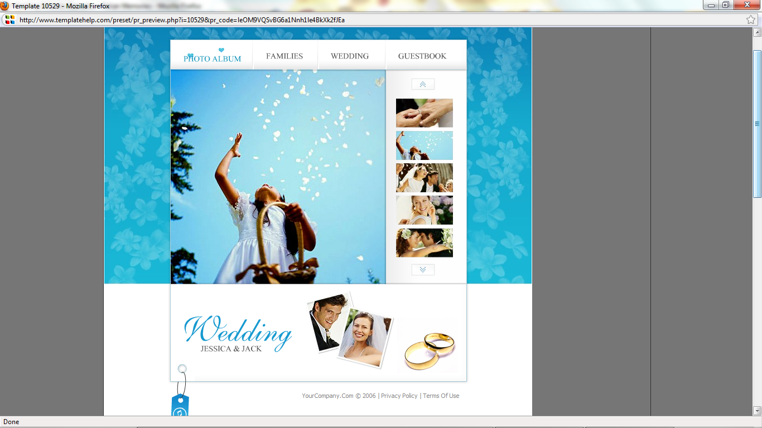

http://www.templatehelp.com/preset/pr_preview.php?i=22865&pr_code=leOM9VQSvBG6a1Nnh1le4BkXk2fJEa

